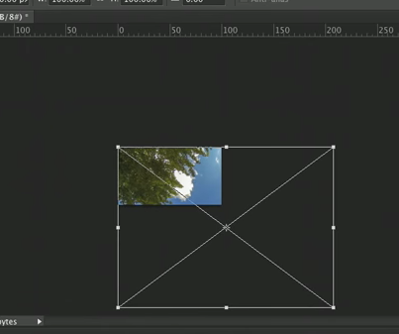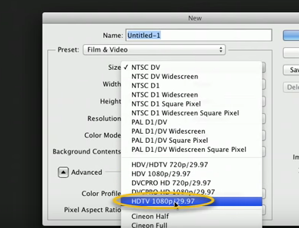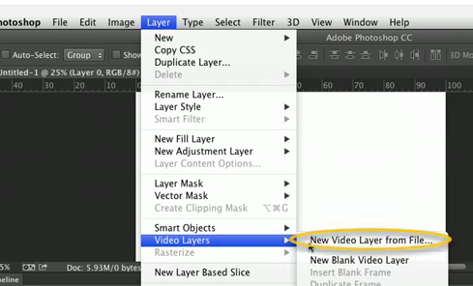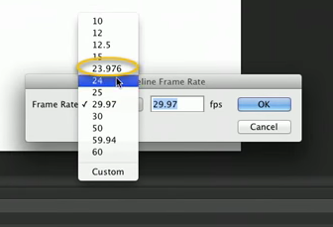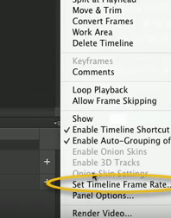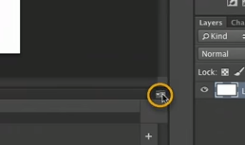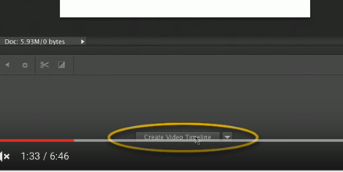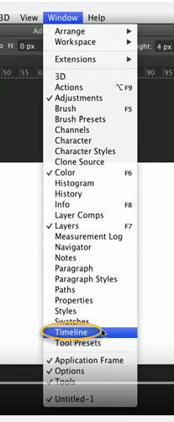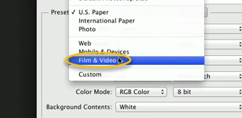

Make a Time Lapse in Photoshop

1. File New
   1. Choose preset – Film & Video – Size HDTV 1080p
2. Window – drop-down – timeline
3. Drag to show timeline area below workspace.
   1. Select create video timeline
4. From the timeline right drop-down button –
   1. Select set timeline frame-rate
   2. Set to 23.976
5. Select layer from top-menu
   1. Video layers – new video layer from file
   2. Choose the first of the set of files for the time lapse
6. Select the image layer – convert to smart object
   1. Zoom your view out to see the edges of the image command+
   2. Shift and drag to shrink the image to the video constraints
7. Do any edits as you would for a single photo
8. Export – render video- pre-set uncompressed

